Case Study No 3

Task 1

class Car_Loan_Management:

def __init__(self,name,nationality,record,age,salary,status):

self.name = name

self.nationality = nationality

self.age = age

self.salary = salary

self.record=record

self.status=status

class customer(Car_Loan_Management):

def __init__(self,name,nationality,record,age,salary,NIC_number,Loan,status):

self.NIC_number = NIC_number

self.Loan = Loan

Car_Loan_Management.__init__(self,name,nationality,record,age,salary,status)

def description_of_customer(self):

print("Name: "+self.name+"\nNationality: "+self.nationality+"\nAge: "+self.age+"\nSalary: "+self.salary+"\nCNIC: "+self.NIC_number+"\nLoan: "+self.Loan+"\nRecord: "+self.record+"\nStatus for an application of loan: "+self.status)

class Customer(Car_Loan_Management):

def __init__(self,name,nationality,record,age,salary,NIC_number,Loan,status):

self.NIC_number = NIC_number

self.Loan = Loan

Car_Loan_Management.__init__(self,name,nationality,record,age,salary,status)

def Description_of_customer(self):

print("\n\nName: "+self.name+"\nNationality: "+self.nationality+"\nAge: "+self.age+"\nsalary: "+self.salary+"\nCNIC: "+self.NIC_number+"\nLoan: "+self.Loan+"\nRecord: "+self.record+"\nStatus for an application of loan: "+self.status)

obj1 = customer("Omer","Pakistani","not clear","19","25000","234383","20000","not agreed")

obj2 = Customer("ismail","Pakistani","clear","19","50000","9473929","5000","agreed")

obj1.description_of_customer()

obj2.Description_of_customer()

OUTPUT:

Name: Omer

Nationality: Pakistani

Age: 19

Salary: 25000

CNIC: 234383

Loan: 20000

Record: not clear

Status for an application of loan: not agreed

Name: ismail

Nationality: Pakistani

Age: 19

salary: 50000

CNIC: 9473929

Loan: 5000

Record: clear

Status for an application of loan: agreed

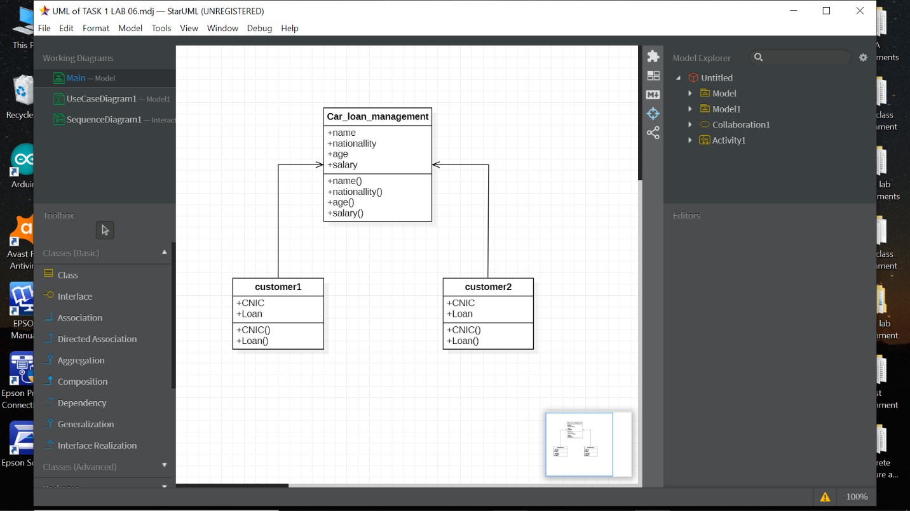

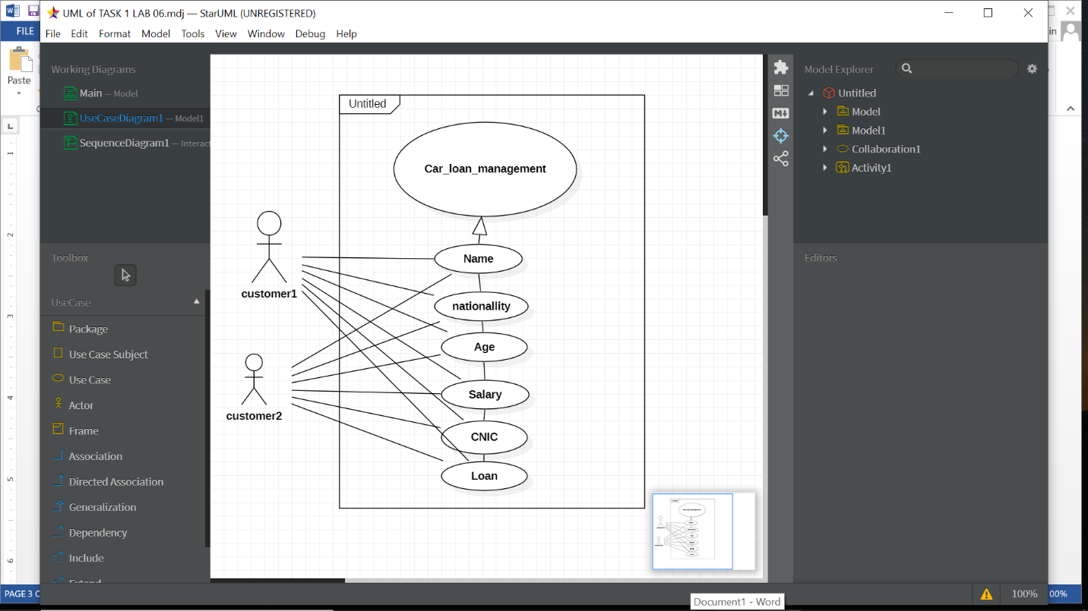

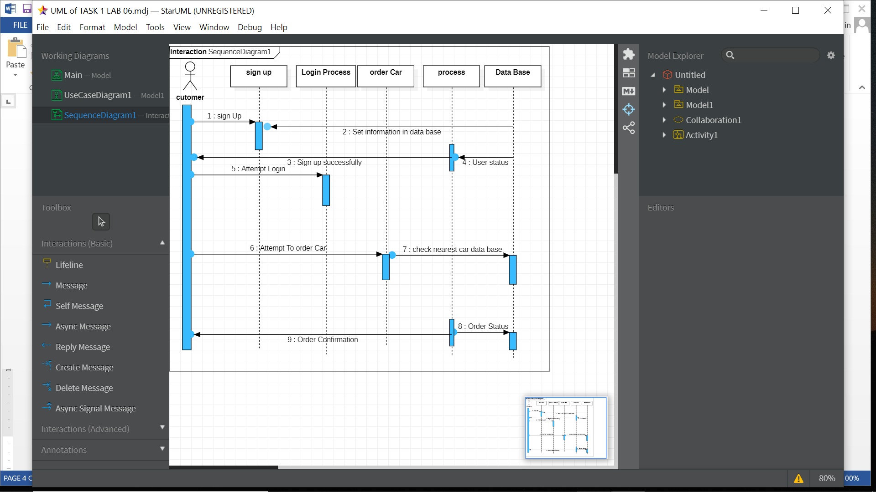

TASK 2

class Cargo_Management_System:

def __init__(self,transaction,billing,status):

self.transaction = transaction

self.billing = billing

self.status=status

class Person(Cargo_Management_System):

def __init__(self,transaction,billing,status,name,age):

self.name = name

self.age = age

Cargo_Management_System.__init__(self,transaction,billing,status)

def description(self):

print("Name: "+self.name+"\nAge: "+self.age+"\nTransaction: "+self.transaction+"\nBilling: "+self.billing+"\n status:"+self.status)

obj = Person("2500","50000","agreed","Omer","19")

obj.description()

OUTPUT:

Name: Omer

Age: 19

Transaction: 2500

Billing: 50000

status:agreed

